NAME: JEEVITHA.S-192324020
DATA BASE MANAGEMENT SYSTEM FOR WEB APPLICATION(CSA0555)
36-Dynamic SQL with a DML Statement
CREATE TABLE EMPLOYEE_details (
employee_id NUMBER PRIMARY KEY,
employee_name VARCHAR2(50)
);
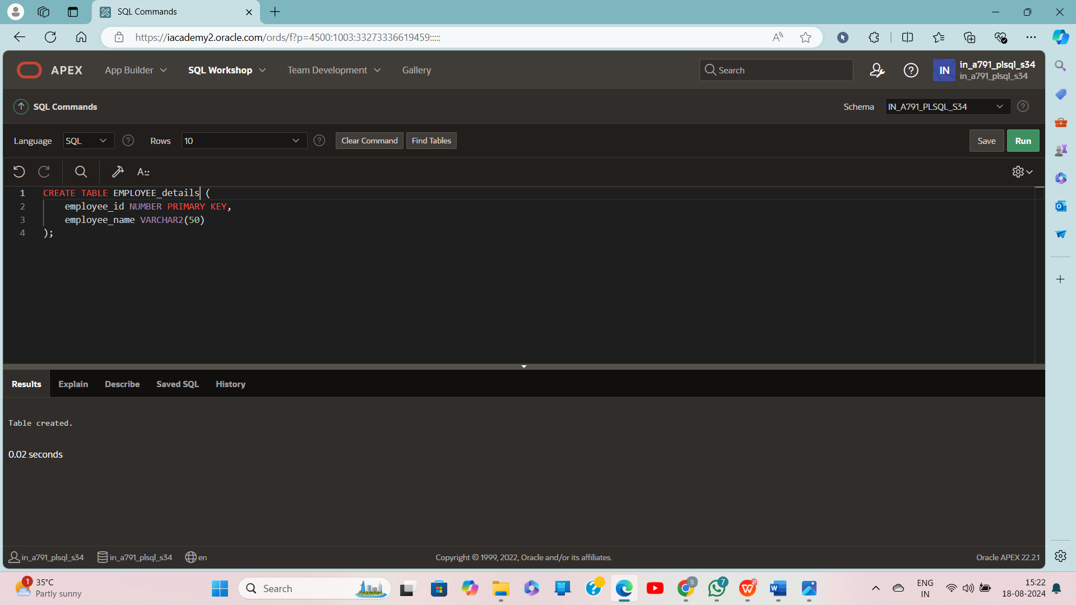

CREATE OR REPLACE PROCEDURE add_row(
p_table_name VARCHAR2,
p_id NUMBER,
p_name VARCHAR2
) IS
BEGIN
EXECUTE IMMEDIATE
'INSERT INTO ' || p_table_name ||
' (employee_id, employee_name) VALUES (' || p_id || ', ''' || p_name || ''')';
END;
/
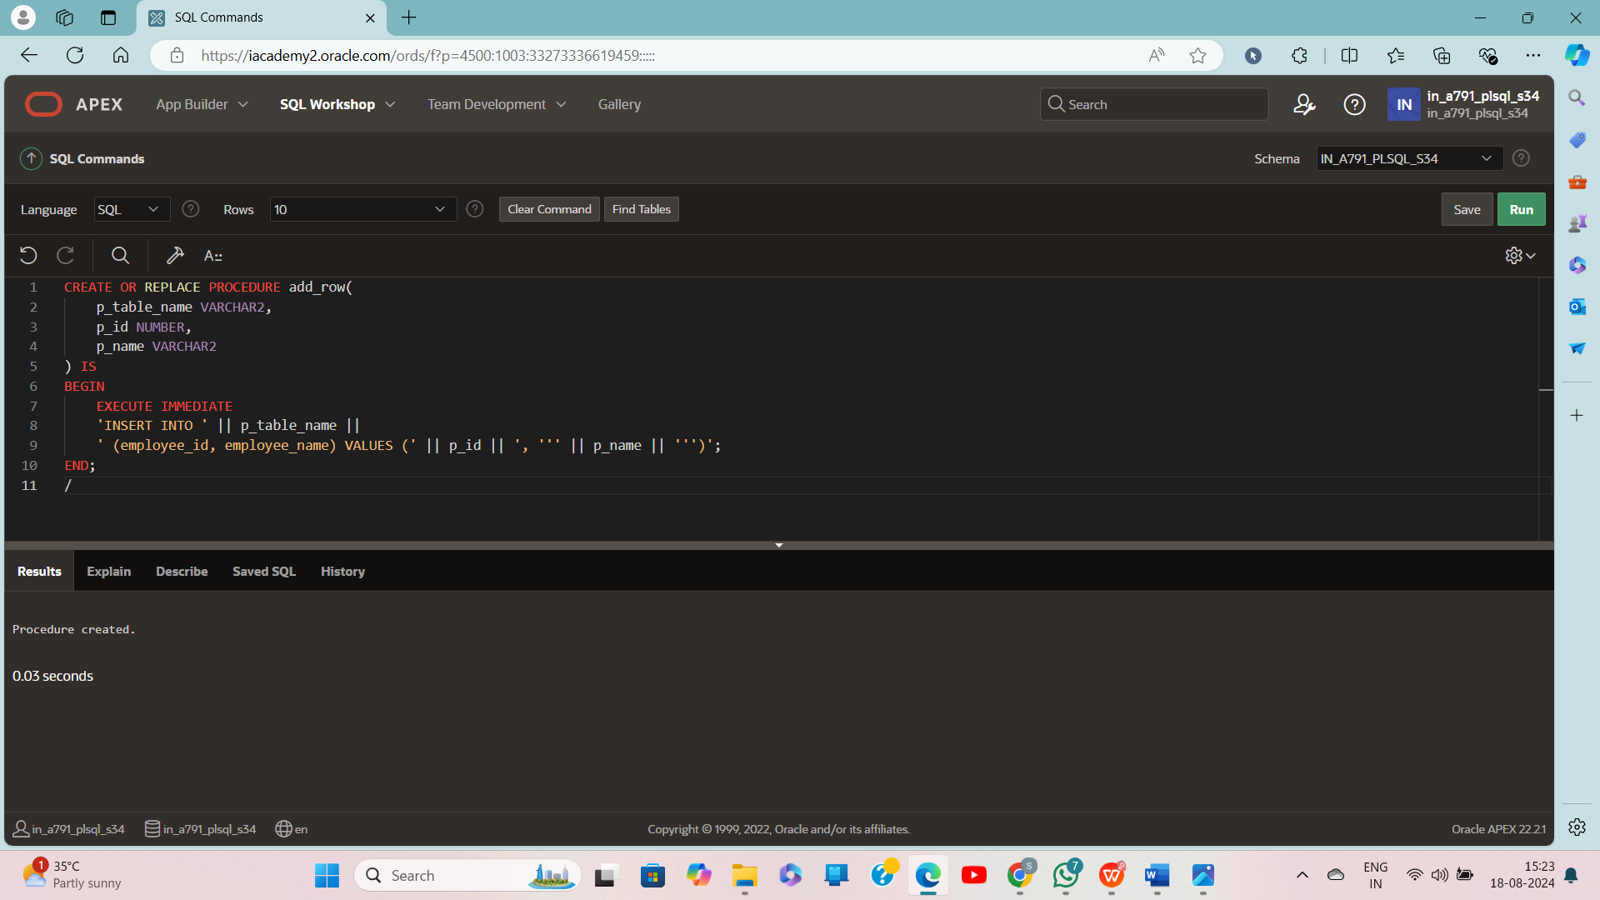
BEGIN
add_row('EMPLOYEE_details', 250, 'Chang');
END;
/
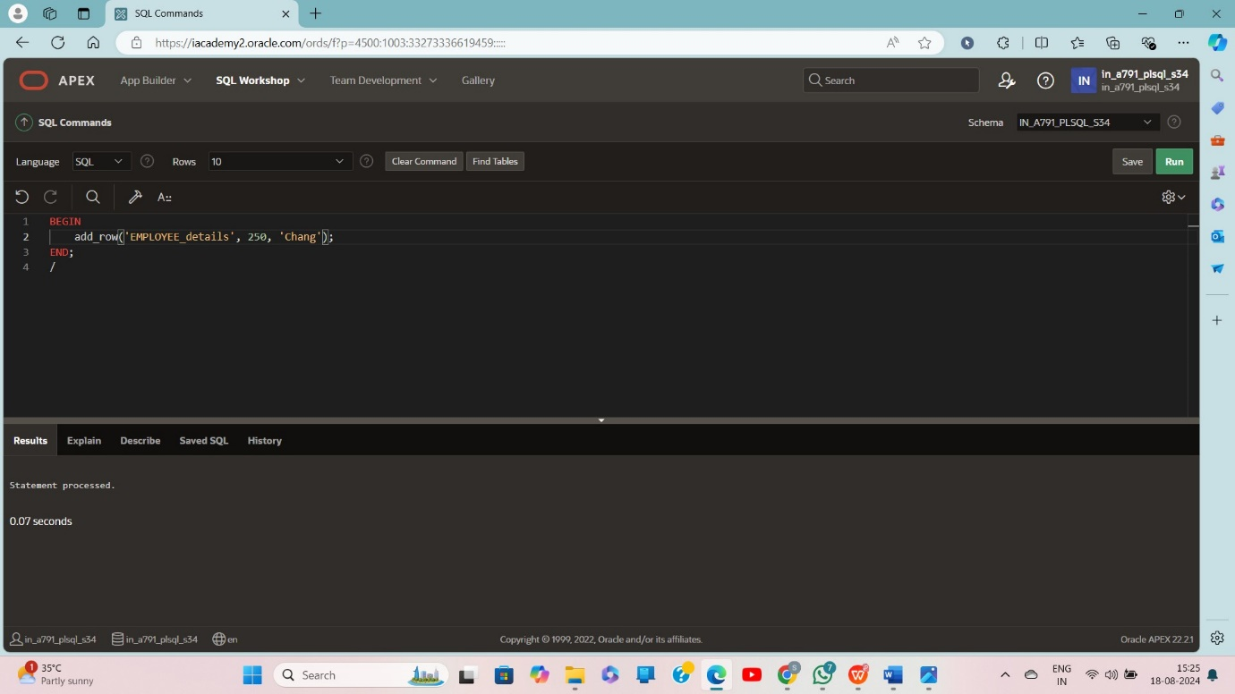

select*from EMPLOYEE_details
